# Humane Society of Utah

# Content Development 3: Media Selection

# Lizz Corrigan | Maxine Dee | Kyle Carsey | Steven Naisbitt | Steven Langman

1. **Describe the objectives and sub-objectives to be covered in this development period**
   * **1.0** Employees will be able to effectively explain the principles and key information of the Humane Society of Utah (***HSU***) to the public.
     + Explain the principles and key information
     + Examine the differences between the HSU and other like organizations
     + Describe the services and programs offered by the HSU
     + Explain what a no-kill shelter is
2. **Describe the new content developed in this period**
   * We started by creating the assets that we will be using throughout our captivate project such as:
     + Cartoon Park Background  
       
     + Map of progression of modules  
       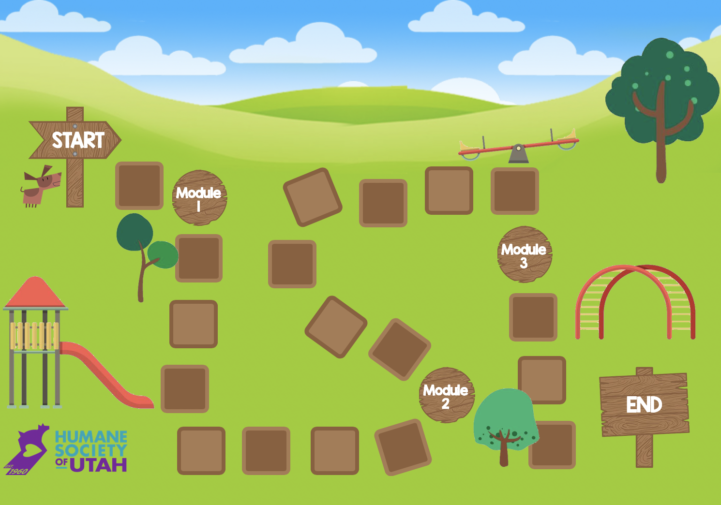
     + Title slides, transition slides, and buttons  
       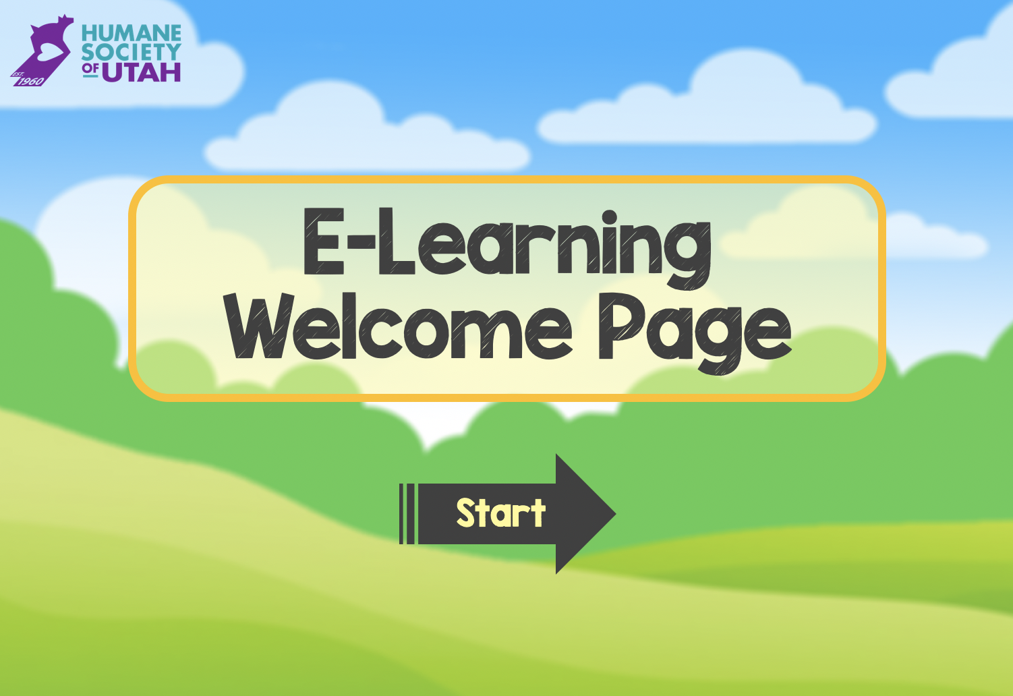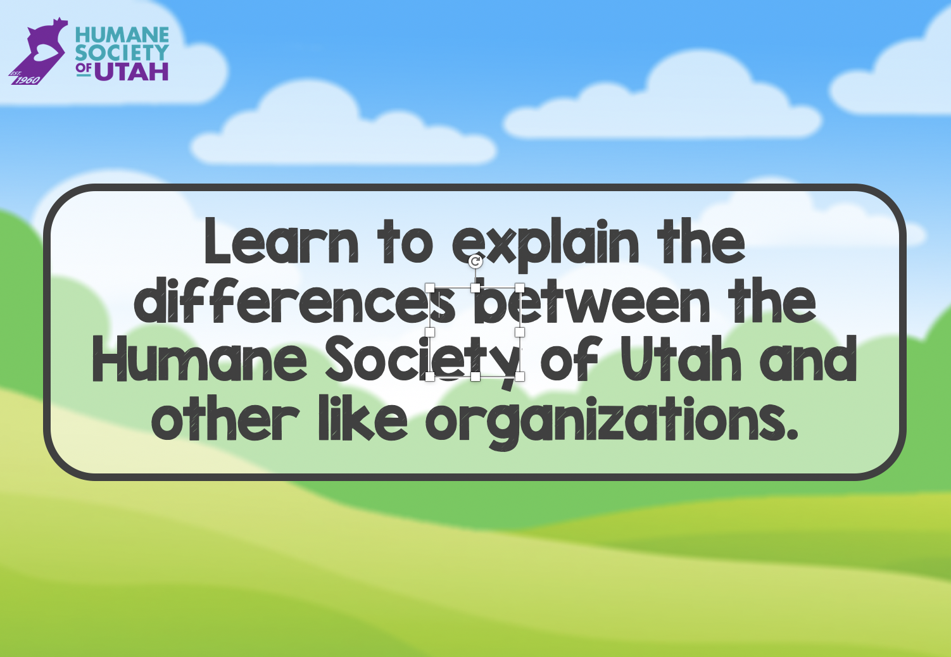
     + Placeholder for videos  
       
   * Gathered assets from [www.vecteezy.com](http://www.vecteezy.com) for cartoon trees, playground equipment, and other items needed for modules. All assets collected are royalty free.
3. **Describe the media used**
   1. **How are the media defined in the timeline?**  
      Media is defined in the timeline by their purpose or name.  
      For example:
      * Animated Dog = Hobbes
      * Park = Background
      * Video Placeholder = Placeholder
      * Arrows = Next or Back Buttons
      * HSU Logo = Logo
      * Title Page = Title Page
   2. **Are there any changes to the media? If yes, explain why? If no, explain why?**
      * There are no significant changes to our media; the biggest change will be including more still photos in our videos.

After meeting with our stakeholder, we learned they have some supporting graphics that will facilitate the learning process for specific information. We are not eliminating the use of our videos. Our stakeholder realized the importance of live-footage videos with supporting graphics in specific instances, while other topics better lend themselves to animated/explainer videos.   
We are keeping our animated character (Hobbes the dog) that will walk learners through the modules, but our stakeholder asked that we change how that character is introduced (“Top Dog” rather than “Service Dog” due to disability concerns/conflicts).   
  
There are no changes to our animated background media. Our stakeholder like the idea of taking specific routes through the park; it is on brand and signifies a journey rather than just a list of tasks to complete.

* 1. **How does the media support learning and objectives?**
     + Our module 1 requires learners to recall information about the HSU. We knew that narration and images would be great media to accomplish our objectives. We also had the challenge of the expectations of our client that video should be included—if not the primary media—in our content.
     + **Redundancy Principle:**   
       People learn better from graphics and narration than from graphics, narration, and on-screen text.
       - We thought of the Redundancy Principle when designing how we could use video and narration and eliminate text on the screen. We simplified our video to mostly be short panning shots of the facility with narration and small graphics. We believe this style focuses on the content only includes visual and audio without distracting components that take away from the learning objective. When focused only on recall we felt like we needed to focus on delivering the content free from over use of media.
  2. **How does the media serve the content presentation and delivery?**

While most of the presentation is simply providing information that the learners need to be aware of and know how to explain, we hope we can deepen learning so there is comprehension and not just rote memorization. For example, throughout the training our character will interrupt the videos and ask a knowledge check question, not just to see if the learner is paying attention but more importantly comprehending. To avoid cognitive overload, it will be a simple question based off of the first 1-2 minutes of information.

At the end of each module, we will have a final interactive quiz question that will require the learner to reason and apply the knowledge -- thus supporting deep learning.